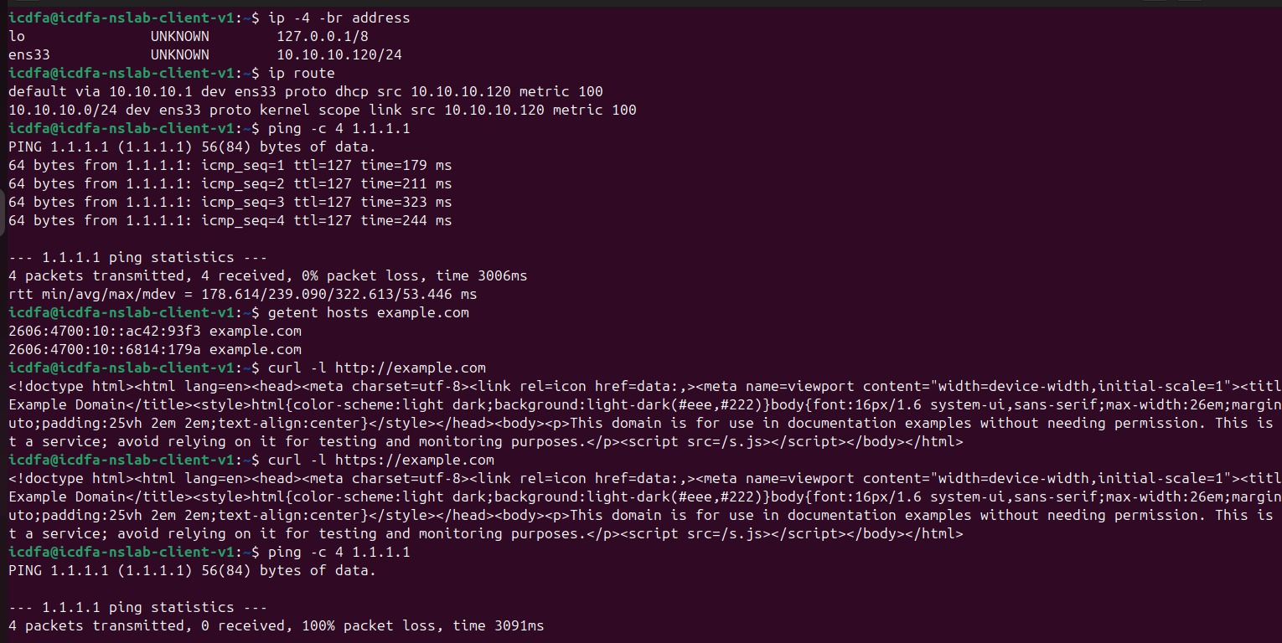
Output showing the Ubuntu client’s IPv4 address and default route, Successful baseline ping to 1.1.1.1, Successful baseline DNS-resolution test, Successful baseline HTTP and HTTPS tests, - Failed ICMP test to 1.1.1.1.
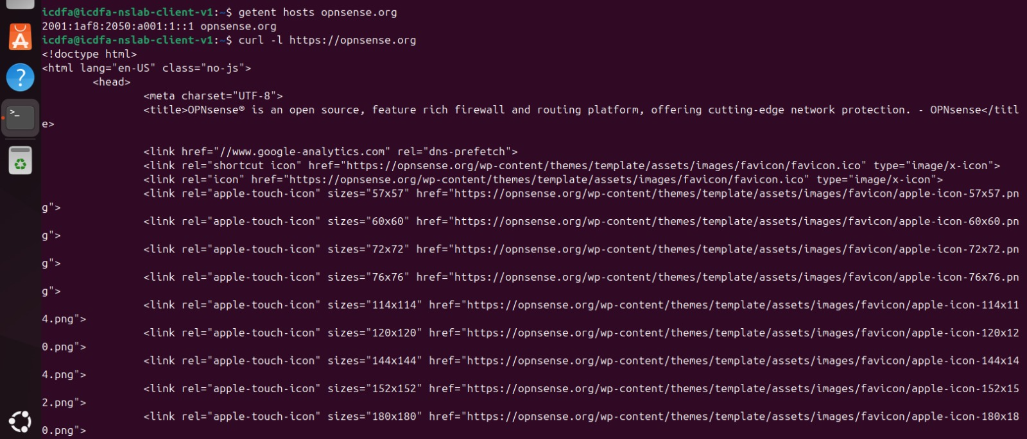
Successful DNS or HTTPS test while ICMP is blocked.
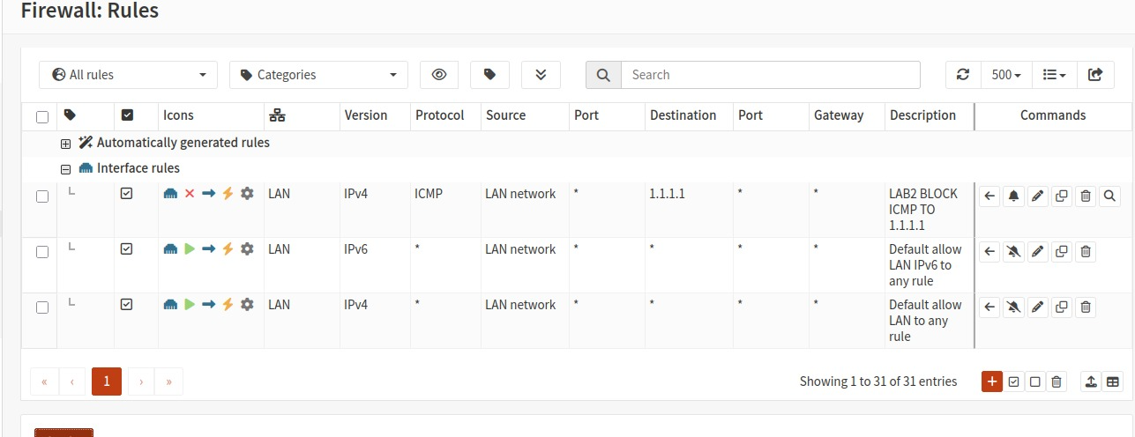
Screenshot showing both temporary block rules above the default allow rule.

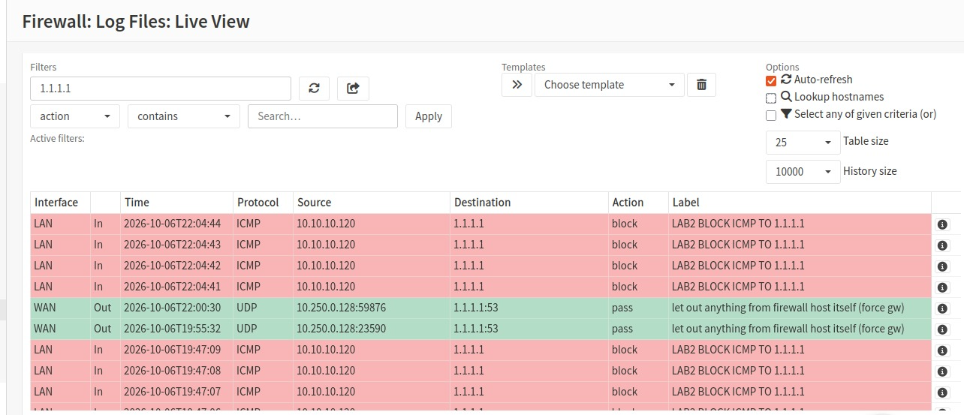
Failed ICMP test to 1.1.1.1.
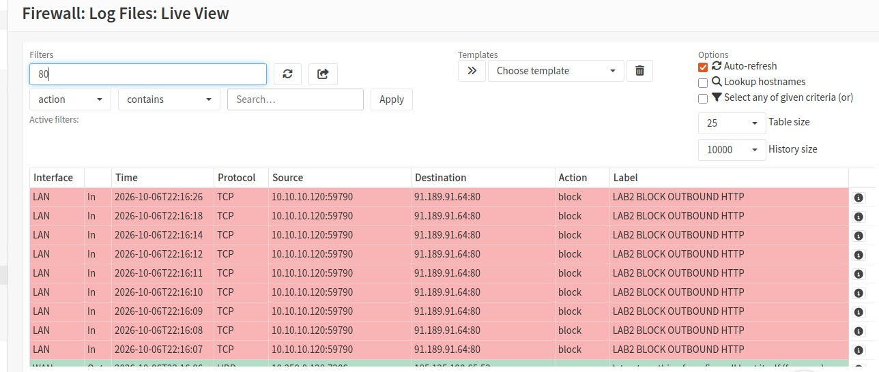
Failed HTTP request on TCP port 80
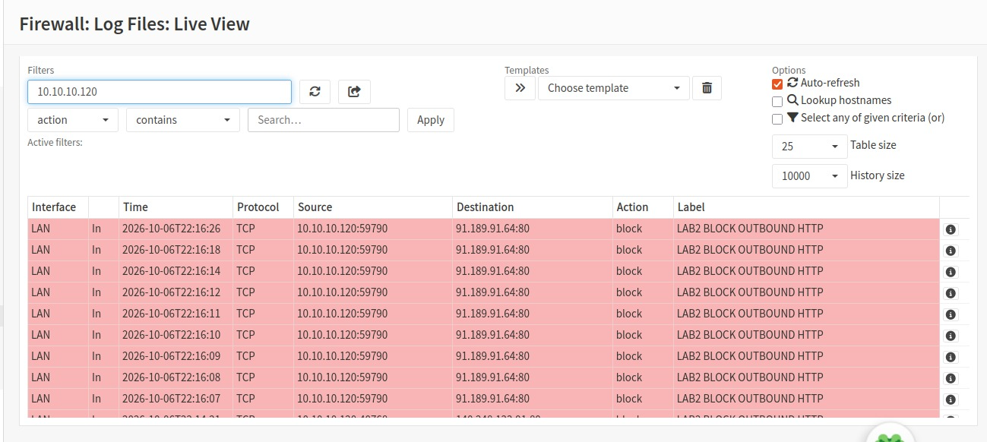
Failed HTTP request on client server
The traffic matched the block rule instead of the default allow rule because OPNsense evaluates firewall rules from top to bottom. The LAB2 BLOCK ICMP TO 1.1.1.1 and LAB2 BLOCK OUTBOUND HTTP rules were placed above the Default allow LAN to any rule, so matching traffic was blocked before it could reach the broader allow rule.

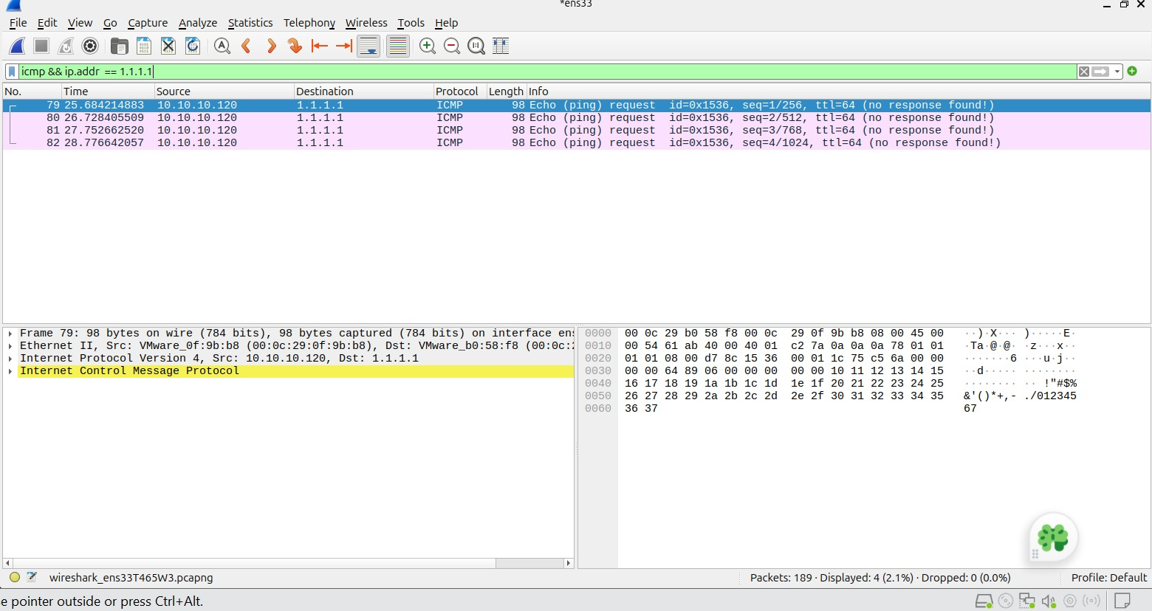
Wireshark capture showing blocked ICMP traffic.
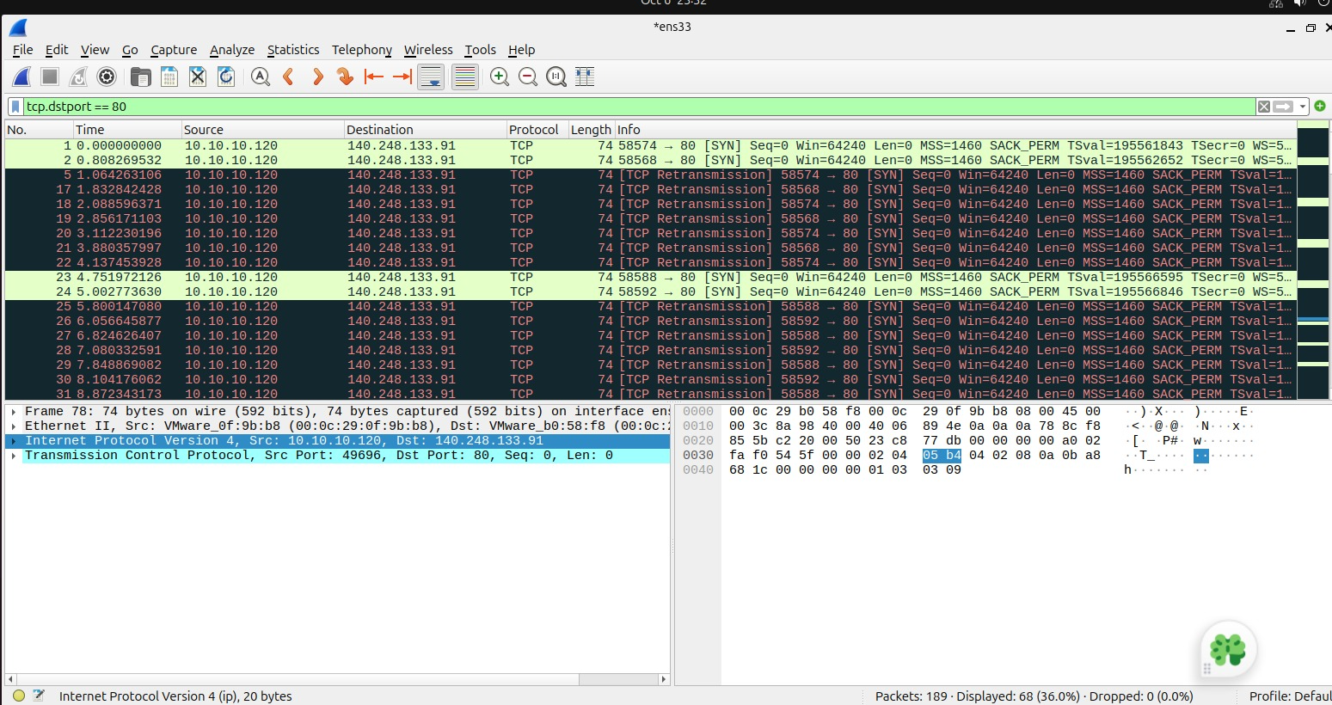
Wireshark capture showing blocked HTTP traffic.
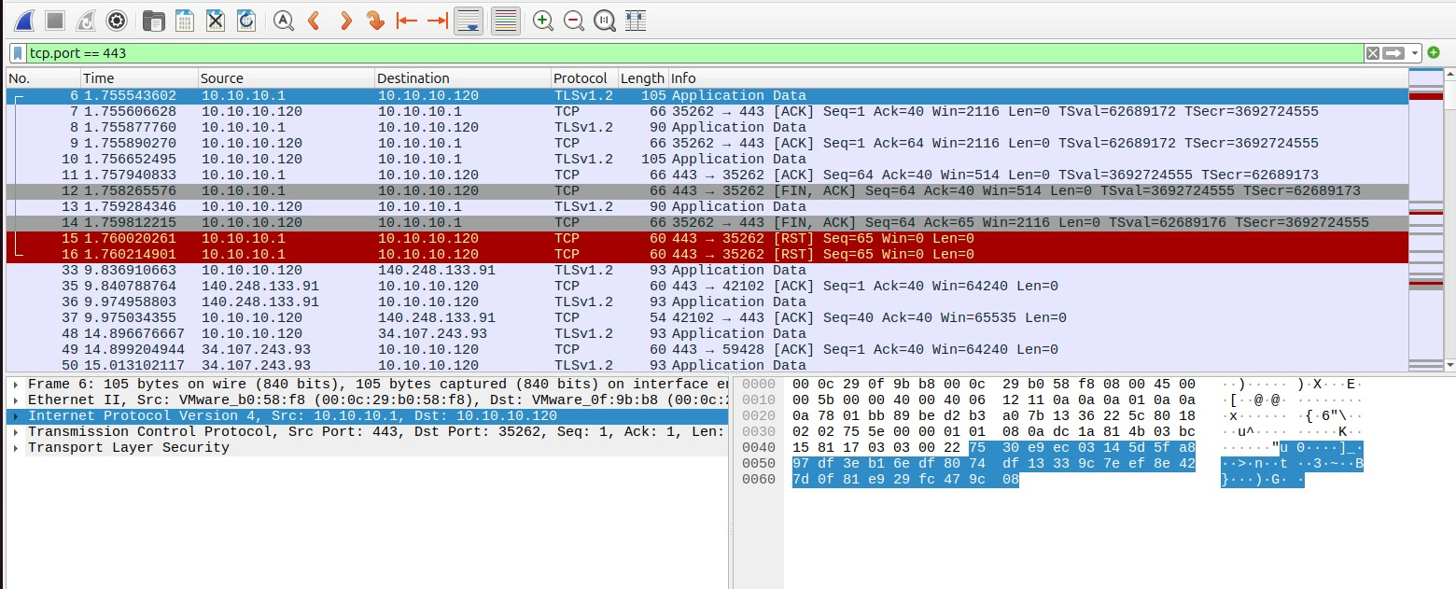
Wireshark capture showing permitted HTTPS traffic.

- OPNsense state-table evidence for a permitted connection.
 | ICMP Filter | HTTP Filter | HTTPS Filter
1. | Display Filter: icmp && ip.addr == 1.1.1.1 | Display Filter: tcp.dstport == 80 | Display Filter: tcp.port == 443
2. | Observation: Echo requests were sent from the Ubuntu client to 1.1.1.1, but no echo replies were received.  Show more lines | Observation: TCP SYN packets were transmitted and retransmitted, but no SYN-ACK response was received because the firewall blocked port 80 traffic. | Observation: A complete TCP handshake occurred followed by TLS encrypted traffic, demonstrating that HTTPS traffic was permitted.  Show more lines

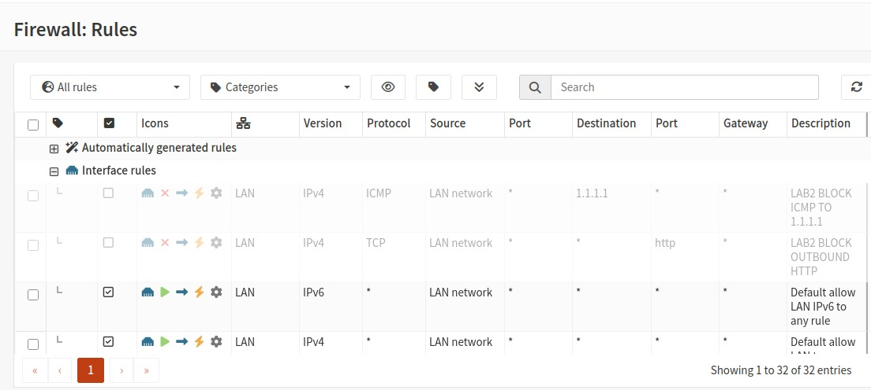
Screenshot showing both laboratory rules disabled.
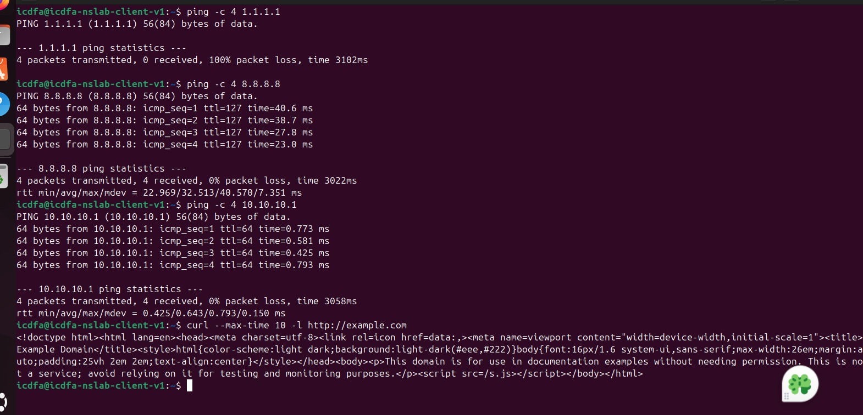
Successful connectivity tests after the rules are disabled.

Analysis questions
1. Why must the specific block rules be placed above the broad allow rule?
OPNsense processes rules from top to bottom, so block rules must come first to take effect.
2. Which five packet attributes are most useful when explaining a firewall decision?
- Source IP
- Destination IP
- Protocol
- Source port
- Destination port
3. Why did blocking ICMP not block HTTPS?
ICMP and HTTPS use different protocols. Blocking ICMP affects ping traffic only, not HTTPS on TCP port 443.
4. What difference did you observe between the blocked TCP port 80 traffic and permitted TCP port 443 traffic?
Port 80 traffic failed to connect, while port 443 traffic successfully established a connection and exchanged data.
5. What role does outbound NAT play when icdfa-nslab-client-v1 uses a private IPv4 address?
Outbound NAT translates the private 10.10.10.x address into a routable WAN address for Internet access.
6. Why is restoring the original state an important part of a controlled security laboratory?
It returns the network to a known working state and prevents test configurations from affecting future activities.

